Design Thinking project report:  
ai smart schedule

|  |
| --- |
| Group 1 |

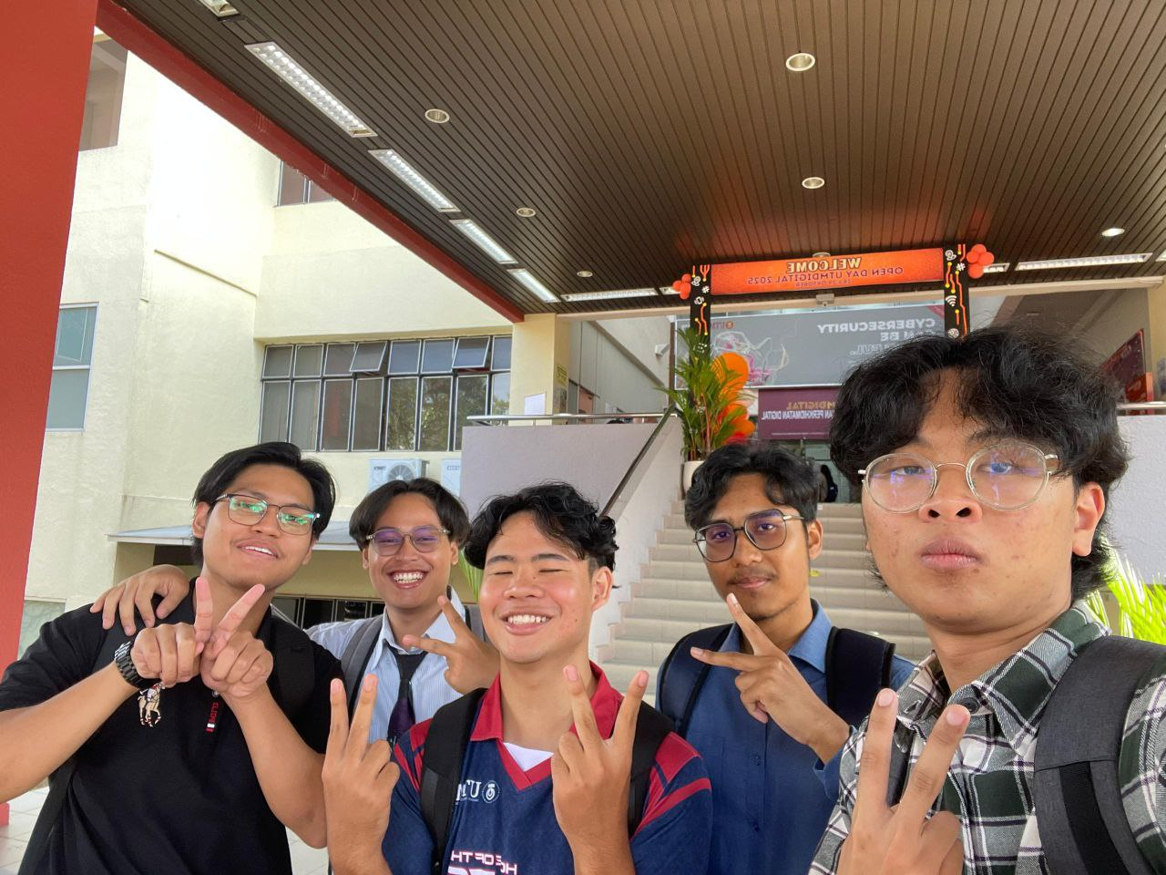

|  |  |
| --- | --- |
| MUHAMMAD AMIR IQMAL BIN MOHD YUSOFF | A25CS0264 |
| MUHAMMAD IQBAL BIN FAIZAL | A25CS0277 |
| AHMAD AZRULAMIN BIN SHAMSURI | A25CS0175 |
| SHARIFUDDIN NAFIS BIN HIZAM | A25CS0348 |
| MUHAMMAD FARIS IQBAL BIN SHARIFFUDDIN | A25CS0270 |

Contents

1. Introduction 3

2. Steps and Descriptions in Design Thinking with Evidence 3

3. Detailed Description of Problem, Solution, and Team Working 4

4. Design Thinking Assessment Points 5

**a. Assessment During the End of the Project Demonstration** 5

**b. Assessment During the Transition Between Design Thinking Phases** 6

5. Design Thinking Evidence 6

**a. Sample Student Work** 6

**b. Record for Each Phase** 9

**i. Empathy** 9

**ii. Define** 10

**iii. Ideate** 10

**iv. Prototype** 10

v. Test 11

6. Reflection 11

**Amir Reflection** 11

**Iqbal Reflection** 11

**Nafis Reflection** 12

**Amin Reflection** 12

**Faris Reflection** 13

7. Prototype 13

# Introduction

Design Thinking is a human centered problem-solving approach that focuses on understanding user needs, redefining problems, generating innovative ideas, building prototypes, and testing solutions. This report documents the application of the Design Thinking methodology in developing AI Smart Schedule, an intelligent scheduling system designed to help users manage time effectively using artificial intelligence.

The project aims to address common issues such as poor time management, overlapping tasks, missed deadlines, and stress caused by inefficient scheduling. By applying the five phases of Design Thinking—Empathy, Define, Ideate, Prototype, and Test. The team worked collaboratively to design a solution that is practical, user-friendly, and impactful.

# Steps and Descriptions in Design Thinking with Evidence

|  |  |  |  |  |  |
| --- | --- | --- | --- | --- | --- |
| WEEK | DESIGN THINKING PHASE | ACTIVITIES CONDUCTED | EVIDENCE | TEAM MEMBER INVOLVED | REFLECTION |
| Week 1 – Week 2 | Empathy | •Discussed project title and scope  •Prepared survey questions  •share the survey |  | All team | Users feel stressed managing time and often forget tasks. Emotional factors affect productivity. |
| Week 3 – Week 4 | Define | •Analyzed survey results  •Identified key problems  •Wrote problem statement |  | Iqbal  Amin | Clear problem definition helped the team focus on user needs instead of assumptions. |
| Week 5 – Week 6 | Ideate | •Brainstormed solutions  •Created mind map  •Selected best idea |  | All members | Many ideas were given. AI-based smart scheduling was chosen as the best solution. |
| Week 9 – Week 10 | Prototype | •Sketched app interface  •Designed low-fidelity prototype  •Internal discussion |  | Iqbal  Amin  Amir | Prototype made the idea clearer and easier to explain to users. |
| Week 11 – Week 12 | Test | •Tested prototype with users  •Collected feedback  •Listed improvements | Double click to view | All Member | Users found the app helpful and easy to use. Improvements needed for reminders and UI clarity. |

# Detailed Description of Problem, Solution, and Team Working

**Problem**

Users struggle with managing time efficiently due to static schedules, lack of adaptability, and stress from overload.

**Solution**

AI Smart Schedule uses artificial intelligence to:

* Analyze tasks
* Suggest optimized schedules
* Adapt schedules based on workload and user input

**Team Working**

* Collaborative brainstorming
* Equal task distribution
* Regular progress meetings
* Shared documentation

# Design Thinking Assessment Points

Assessment in Design Thinking should be conducted continuously to ensure that students apply each phase effectively and develop a meaningful, user-centered solution. For the AI Smart Schedule project, assessment is most appropriate at two key points: at the end of the project demonstration and during transitions between Design Thinking phases.

## **a. Assessment During the End of the Project Demonstration**

Assessment at the end of the project should focus on evaluating the overall quality and effectiveness of the final solution. This includes assessing how well the AI Smart Schedule prototype addresses the identified user problems, the clarity of the design concept, and the functionality of the prototype.

At this stage, assessors can evaluate:

* The final prototype and its usability
* The relevance of the solution to user needs
* The quality of visual design and multimedia elements
* The clarity of presentation and explanation
* Evidence of applying all Design Thinking phases

This type of assessment allows evaluators to measure the overall learning outcome and the students’ ability to translate design thinking concepts into a complete and functional solution.

## **b. Assessment During the Transition Between Design Thinking Phases**

Assessment should also be conducted during transitions between each Design Thinking phase to ensure that students do not move forward without fully completing the previous stage. For example, assessment between the empathy and define phases ensures that user research has been properly conducted and analyzed.

At these transition points, assessment may include:

* Review of empathy findings such as interview results and personas
* Evaluation of problem statements and defined user needs
* Review of brainstorming outputs and idea justification
* Feedback on prototype development before testing

This continuous assessment approach encourages reflection, improvement, and iterative learning. It helps students refine their ideas, correct misunderstandings early, and strengthen the quality of the final solution.

# Design Thinking Evidence

## **a. Sample Student Work**

* Survey questions and responses

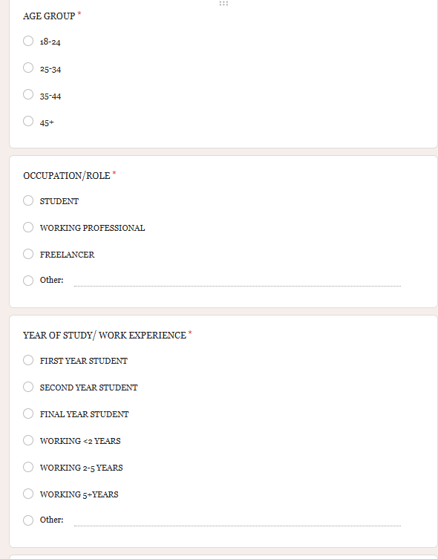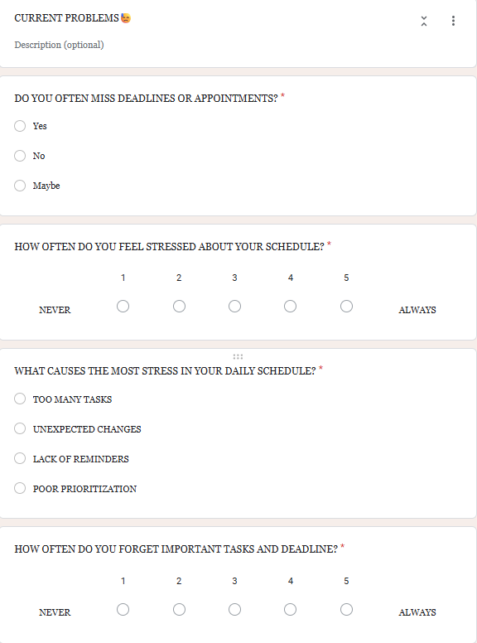

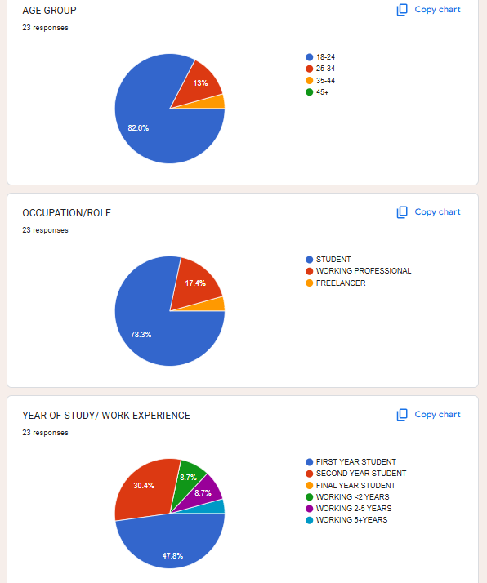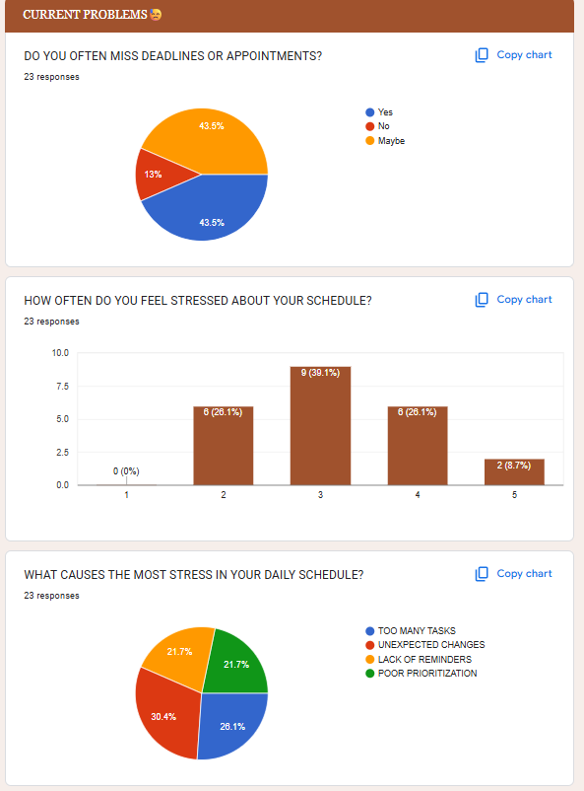

* Brainstorm sketches

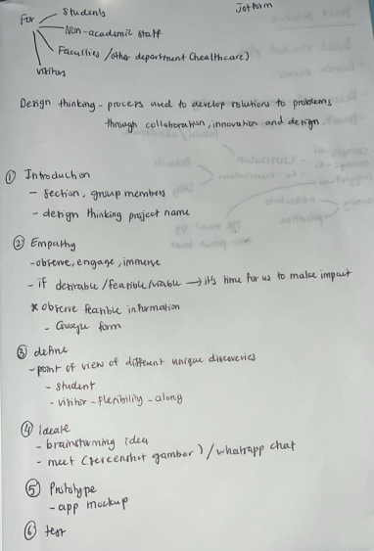

* Prototype screenshots

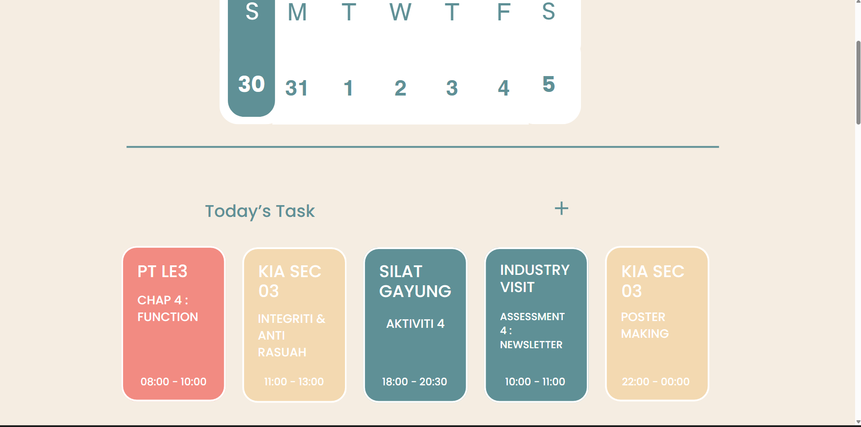

## **b. Record for Each Phase**

### **i. Empathy**

**Sample Questions & Answers:**

* *Q: WHAT CAUSES THE MOST STRESS IN YOUR DAILY SCHEDULE?*
  + A: TOO MANY TASKS
  + A: UNEXPECTED CHANGES
  + A: LACK OF REMINDERS
  + A: POOR PRIORITIZATION
* *Q: WHICH FEATURES WOULD YOU VALUE MOST IN A SMART SCHEDULE?*
  + A: AUTOMATIC PRIORITIZATION OF TASKS
  + A: PRESONALIZED REMINDERS
  + A: INTEGRATION WITH APPS (WHATSAPP, EMAIL, ETC.)
  + A: WELLNESS TRACKING (STUDY/REST BALANCE)

**Composite Character (Persona):**

* Name: Alex
* Age: 21
* Background: University student
* Behavior: Busy, multitasking, tech-savvy
* Needs: Smart reminders, balanced schedule

### **ii. Define**

**List of Defined Needs:**

* Users need adaptive scheduling
* Users need motivation and reminders
* Users need stress reduction
* User need AI suggestion
* User need integration with apps (whatsapp, email, etc.)

### **iii. Ideate**

**Brainstorm Process:**

* Individual idea generation
* Group discussion
* Idea filtering
* Final concept selection

### **iv. Prototype**

**Development Process:**

* Sketching interfaces
* Creating digital wireframes
* Refining features based on feedback

### v. Test

**Testing Process:**

* Users tested the prototype
* Feedback collected and analyzed
* Improvements suggested

# Reflection

## **Amir Reflection**

**a. Goal/Dream**  
My goal is to become a professional graphic and multimedia designer who can create meaningful and user-friendly digital products. I aim to combine creativity with technology to produce designs that solve real-world problems.

**b. Impact of Design Thinking**  
The AI Smart Schedule project helped me understand the importance of user-centered design in graphic and multimedia work. Design Thinking taught me how to design based on user emotions, behaviors, and needs, which is essential in creating effective visual and interactive designs.

**c. Action / Improvement Plan**  
To improve my potential in the industry, I plan to strengthen my design skills, master multimedia tools, and practice applying design thinking in future projects. I also aim to build a strong design portfolio.

## **Iqbal Reflection**

**a. Goal/Dream**  
My dream is to work in the creative industry as a multimedia designer, producing engaging visual content and interactive applications.

**b. Impact of Design Thinking**  
This project showed me how Design Thinking improves the quality of design solutions. By understanding users first, I learned to create visuals and interfaces that are not only attractive but also functional and meaningful.

**c. Action / Improvement Plan**  
I plan to improve my skills in UI/UX design, animation, and visual storytelling. Gaining experience through projects, competitions, and internships will help me prepare for the industry.

## **Nafis Reflection**

**a. Goal/Dream**  
My goal is to become a creative professional who specializes in interactive media and digital design.

**b. Impact of Design Thinking**  
The AI Smart Schedule project helped me realize that good multimedia design must be based on user needs. Design Thinking guided me to balance creativity with usability, which is crucial for successful multimedia products.

**c. Action / Improvement Plan**  
To improve my industry readiness, I plan to practice more design projects, learn new multimedia software, and continuously improve my creative and technical skills.

## **Amin Reflection**

**a. Goal/Dream**  
My dream is to contribute to the creative and digital media industry by designing innovative and visually appealing applications.

**b. Impact of Design Thinking**  
Design Thinking helped me understand that design is not only about visuals but also about solving user problems. The project trained me to think critically, receive feedback, and improve designs through iteration.

**c. Action / Improvement Plan**  
I plan to improve my design process, communication skills, and ability to accept feedback. Participating in real-world projects and internships will further enhance my professional skills.

## **Faris Reflection**

**a. Goal/Dream**  
My goal is to become a skilled graphic and multimedia designer who can create impactful digital experiences.

**b. Impact of Design Thinking**  
Through this project, I learned how Design Thinking supports creativity and innovation in multimedia design. It helped me design solutions that are user-focused, functional, and visually effective.

**c. Action / Improvement Plan**  
To improve my potential in the industry, I plan to develop a strong portfolio, explore UI/UX and motion graphics, and stay updated with current design trends and technologies.

# Prototype

https://aismartschedule.my.canva.site/